When we reate a account I azure, a directory is created . This directory is called Tenant , AD Tenant

Every subscription is binded to only one Active Directory

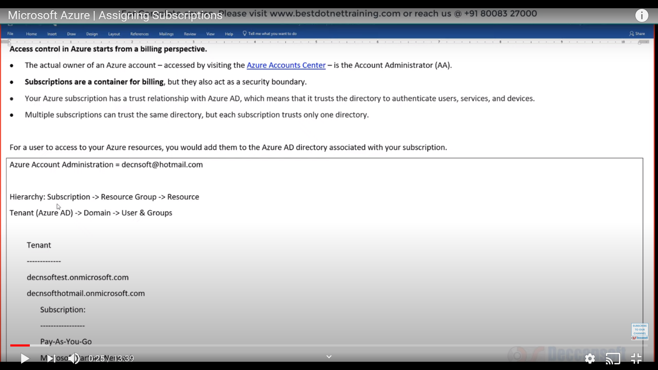

Account Adminstrator has created a subscription. And now the account administrator has to give access to other users , the subscription so that they can create services in that

When we create an account in Azure , like I did with [Anamika.sawhney22@gmail.com](mailto:Anamika.sawhney22@gmail.com), it creates a Azure AD by default. So, if I have mutiple accounts, there will be a default AD.

Check Active Directory

Focus on Users. There will be users who belong to your organisation , some you have invited as a guest in your AD. For every AD, there is a domain. By default the domain name ends with Microsoft.com. that will be provided to you.

That is ur primary domain name.

By just adding users does not give them access to the subscription

NO

We are only creating their identity in our organisation

We are only making their presence in Azure AD, but they still cant do anything

For Guest users, once they accept they will not come to this portal, rather they will go to access

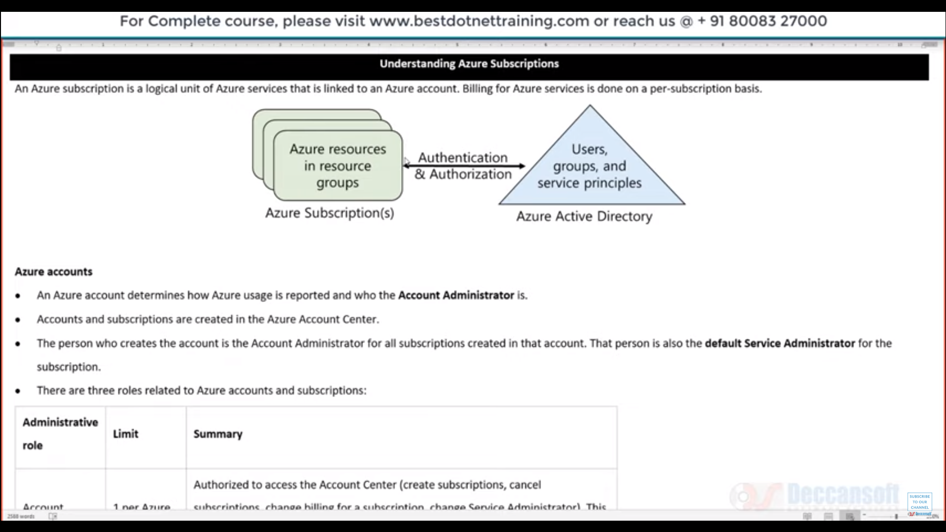

When we create account in Azure, nothing happens without a subscription

It’s a logical unit of Azure services that are linked to an account

There are two types of Administartors

Account Admin

Service Admin

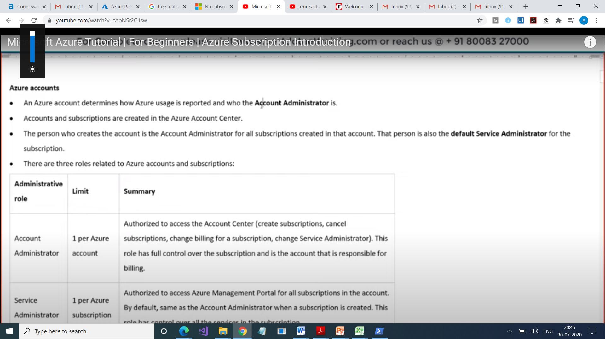

Account Adm who creates an account on account of a corporate than same person is every admin too. But he can create a separate service administrator

